ASSIGNMENT

**Trigger Q2**

Create a transparent audit system for a table clientmaster. The system has to keep track of

records that have been removed or modified and when they have been removed or modified. Table

details are given below:

AuditClient: name, bal_due, operation, Op_date

Clientmaster: c_no, name, address, bal_due



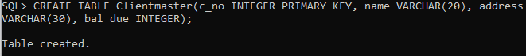

Trigger function:

CREATE OR REPLACE TRIGGER t

AFTER UPDATE OR DELETE ON Clientmaster

FOR EACH ROW

BEGIN

IF (UPDATING) THEN

INSERT INTO AuditClient VALUES(:new.name, :new.bal_due, ‘UPDATE’, SYSDATE);

ELSE

INSERT INTO AuditClient VALUES(:old.name, :old.bal_due, ‘DELETE’, SYSDATE);

END IF;

END;

